Multiple-choice section – choose the correct answer

Question 1 [7.1]

‘Five more than a number gives a solution of 12’ is:

A *n* + 5 = 12 B 5*n* = 12 C 5 − *n* = 12 D 12 = *n*

Question 2 [7.1]

Use substitution to find the value of *a* in 3*a* + 5 = 11

A *a* = 6 B *a* = -6 C *a* = 2 D *a* = -2

Question 3 [7.2]

Solve 3*x* = 9.

A *x* = 3 B *x* = 27 C *x* = D *x* = 6

Question 4 [7.2]

What is the value of *y* where *x* = 2?

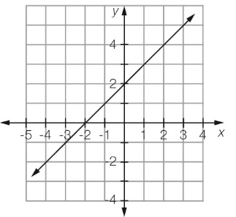

A *y* = 0 B *y* = 3 C *y* = 4 D *y* = 2

Question 5 [7.4]

The solution of the balance diagram is:

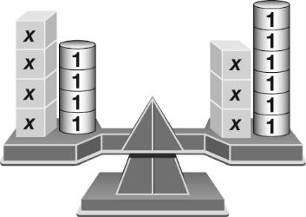

A *x* = 2 B *x* = -2 C 4*x* = 3*x* – 2 D *x* = 3

Question 6 [7.2]

Solve 3*b* + 1 = 16.

A *b* = 45 B *b* = 5 C *b* =  D *b* = 12

Question 7 [7.3]

Solve 2(*x* − 1) = 6.

A *x* = 13 B *x* = 11 C *x* = 7 D *x* = 4

Question 8 [7.4]

Solve 5*d* + 4 = 16*d* – 7.

A *d* = 12 B *d* = -1 C *d* = 11 D *d* = 1

Question 9 [7.5]

Jack buys 3 pens and gets $6.40 change from $10.00. How much is the cost of a pen?

A $2.10 B $1.20 C $3.60 D 70 cents

Multiple-choice results: ___ / 9

Short answer section

Question 10 1 mark [7.3]

Here is Sara’s working to solve the equation  – 1 = 15. Sara has made an error. Circle the line of working where the error appears.

Sara’s working

 − 1 = 15

 = 16

*x* = 4

Question 11 1 mark [7.2]

This graph describes the costs to hire a taxi. What is the cost of hiring a taxi to travel  
a distance of 5 km?

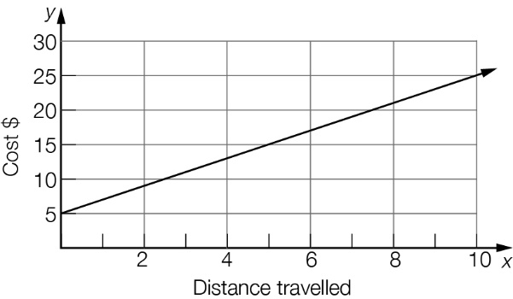

Question 12 1 mark [7.1]

Write an equation for the following using the letter *n* to represent the number.

The sum of a number and 3 makes a total of seven.

Question 13 2 marks [7.1]

Check by substitution whether the number in the brackets is a solution for the equation.

 = 20 (*x* = 4)

Question 14 1 mark [7.1]

Write an equation for the rule below, using the given pronumerals for each of the   
quantities described.

The number of red marbles (*R*) in a bag is five less than twice the number of blue marbles (*B*).

Question 15 4 marks [7.2]

Use the following graph to find the value of:

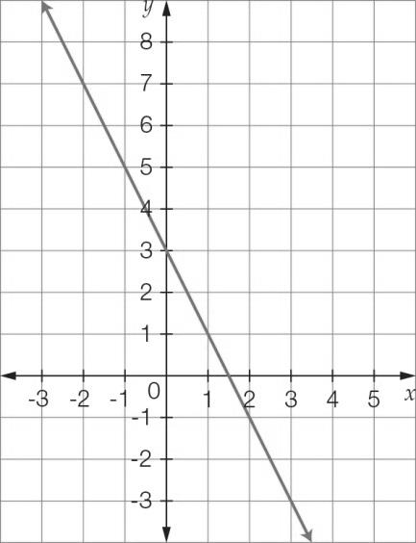

(a) *y* where *x* = 3 (b) *y* where *x* = -1



(c) *x* where *y* = -1 (d) *x* where *y* = 3

Question 16 4 marks [7.3]

Solve each of these linear equations using algebra.

(a) (b)  
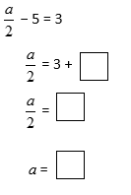 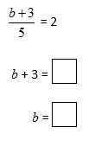

Question 17 3 marks [7.2]

Vinh buys a sandwich each school day for lunch. Twice a week, he also buys a juice for $3.00. He spends a total of $23.50 over the five days.

(a) Write an equation to represent this statement.

(b) How much does a sandwich cost?

Question 18 3 marks [7.3]

Solve the following equation.

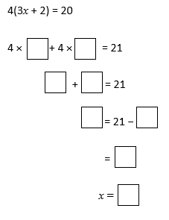

Question 19 6 marks [7.2]

Write the following statements as equations and then find the value of the unknown.

(a) The sum of three times a number and one is ten. What is the number?

(b) A number is doubled and then has six subtracted from it. The result is eight. What is the number?

Question 20 2 marks [7.4]

Use the diagram to calculate the value of *x*.

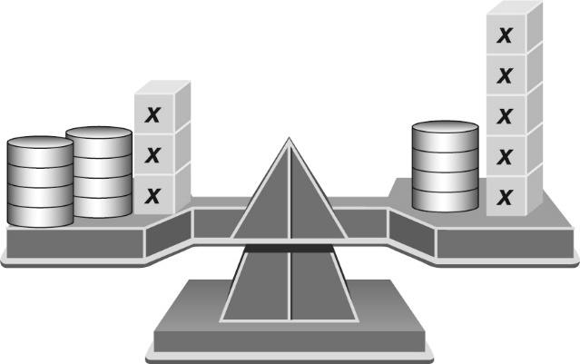

Question 21 3 marks [7.4]

Complete the first line of working and then complete the solution to the equation.

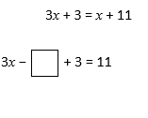

Question 22 3 marks [7.4]

By drawing the lines *y* = *x* and *y* = 2 − *x* on the number plane below, use the point of intersection to solve the equation *x* = 2 − *x*.

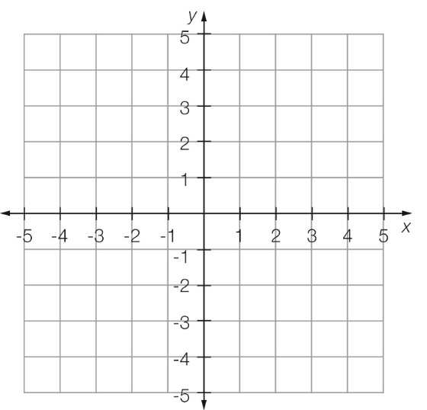

Short answer results: ___ / 34

Extended answer section

Question 23 7 marks [7.3, 7.4, 7.5]

A pool is three times as long as it is wide. The owner wishes to place a row of tiles along the edge and calculates that he needs 32 m of tiles.

(a) Clearly label the measurements in terms of *w* on the diagram below.

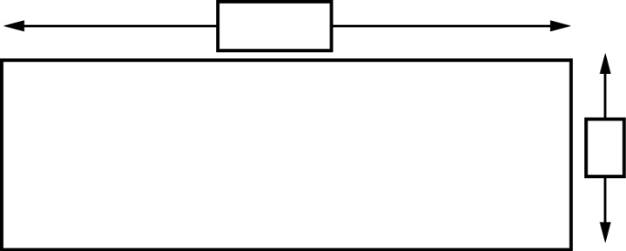

(b) Write an equation for the perimeter (*P*) of the pool.

(c) Calculate the dimensions of the pool using the above equation.

(d) Each tile is 20 cm wide and costs 50 cents. Calculate the cost of placing a row of tiles along the perimeter of the pool.

Extended answer results: ___ / 7

TOTAL test results: ___ / 50